**Figure 1. Averaged Sanitation Indexes for Total and Four Subgroups of Countries (1990~2015)**

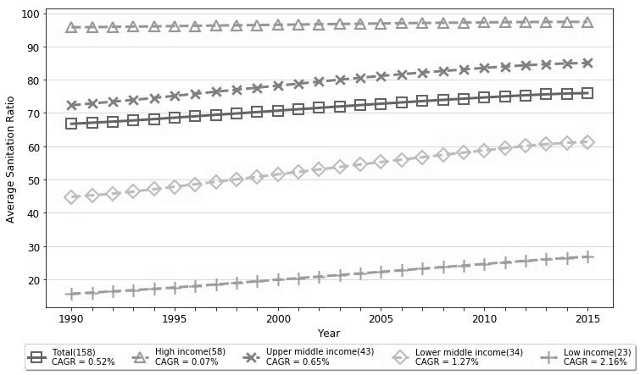

**Figure 2. Normalized Sigma and Gamma Sanitation Indexes for Total Group of 158 Countries (1990-2015)**

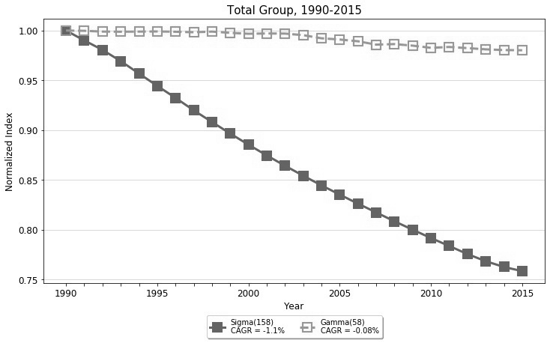

**Figure 3. Normalized Sigma Sanitation Indexes for Four Income Subgroups (1990-2015)**

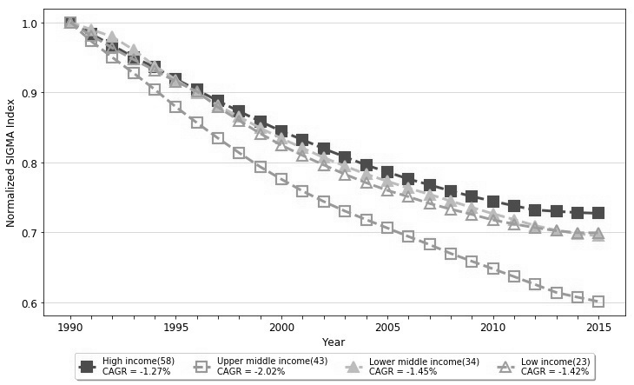

**Figure 4. Normalized Gamma Sanitation Indexes for Four Income Subgroups (1990-2015)**

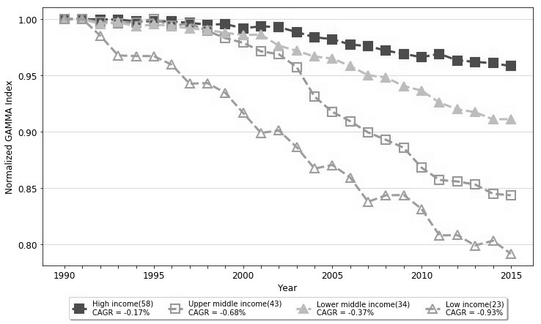

**Figure 5. Normalized Sigma Sanitation Indexes for Six Regional Subgroups (1990-2015)**

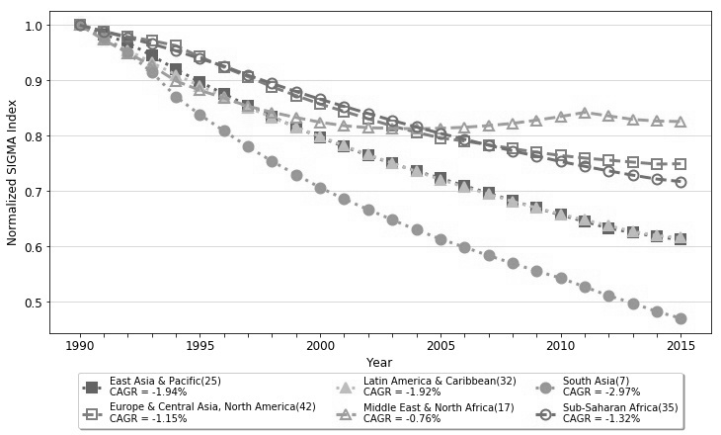

**Figure 6. Normalized Gamma Sanitation Indexes for Six Regional Subgroups (1990-2015)**

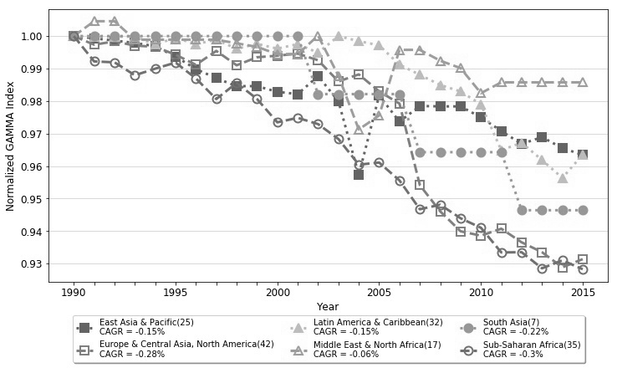

**Table 1. Averaged Sanitation Ratios for Total and Four Subgroups of Countries (1990~2015)**

|  |  |  |  |  |  |
| --- | --- | --- | --- | --- | --- |
| **Sanitation Ratio** | **Total  (158)** | **High  (58)** | **Upper Middle (43)** | **Lower Middle (34)** | **Low  (23)** |
| **1990** | 66.75 | 95.74 | 72.32 | 44.78 | 15.69 |
| **1991** | 67.08 | 95.81 | 72.87 | 45.27 | 16.04 |
| **1992** | 67.40 | 95.88 | 73.40 | 45.75 | 16.40 |
| **1993** | 67.77 | 95.96 | 73.93 | 46.39 | 16.78 |
| **1994** | 68.16 | 96.02 | 74.51 | 47.11 | 17.16 |
| **1995** | 68.59 | 96.11 | 75.15 | 47.85 | 17.58 |
| **1996** | 69.01 | 96.19 | 75.77 | 48.59 | 18.00 |
| **1997** | 69.44 | 96.27 | 76.40 | 49.34 | 18.50 |
| **1998** | 69.86 | 96.34 | 77.00 | 50.07 | 18.96 |
| **1999** | 70.28 | 96.42 | 77.61 | 50.81 | 19.42 |
| **2000** | 70.70 | 96.51 | 78.21 | 51.56 | 19.91 |
| **2001** | 71.12 | 96.58 | 78.81 | 52.30 | 20.38 |
| **2002** | 71.54 | 96.66 | 79.41 | 53.04 | 20.85 |
| **2003** | 71.96 | 96.74 | 80.01 | 53.77 | 21.33 |
| **2004** | 72.38 | 96.82 | 80.58 | 54.52 | 21.80 |
| **2005** | 72.79 | 96.90 | 81.14 | 55.25 | 22.28 |
| **2006** | 73.18 | 96.98 | 81.65 | 55.98 | 22.75 |
| **2007** | 73.56 | 97.04 | 82.15 | 56.71 | 23.22 |
| **2008** | 73.94 | 97.11 | 82.62 | 57.42 | 23.70 |
| **2009** | 74.30 | 97.17 | 83.09 | 58.10 | 24.17 |
| **2010** | 74.66 | 97.22 | 83.55 | 58.77 | 24.64 |
| **2011** | 75.00 | 97.27 | 83.98 | 59.41 | 25.12 |
| **2012** | 75.33 | 97.32 | 84.33 | 60.09 | 25.58 |
| **2013** | 75.62 | 97.35 | 84.67 | 60.63 | 26.03 |
| **2014** | 75.84 | 97.37 | 84.89 | 61.06 | 26.46 |
| **2015** | 75.99 | 97.39 | 85.03 | 61.33 | 26.78 |
| **CAGR (%)** | 0.52% | 0.07% | 0.65% | 1.27% | 2.16% |

**Table 2. Normalized Sigma and Gamma Sanitation Indexes of Total Group of 158 Countries (1990-2015)**

|  |  |  |
| --- | --- | --- |
|  | **All Countries (158)** | |
| **year** | **Sigma** | **Gamma** |
| **1990** | 1.0000 | 1.0000 |
| **1991** | 0.9901 | 0.9997*** |
| **1992** | 0.9806 | 0.9990*** |
| **1993** | 0.9693 | 0.9988*** |
| **1994** | 0.9568 | 0.9989*** |
| **1995** | 0.9444 | 0.9991*** |
| **1996** | 0.9324 | 0.9988*** |
| **1997** | 0.9199 | 0.9983*** |
| **1998** | 0.9082 | 0.9989*** |
| **1999** | 0.8966 | 0.9977*** |
| **2000** | 0.8855 | 0.9968*** |
| **2001** | 0.8747 | 0.9971*** |
| **2002** | 0.8643 | 0.9970*** |
| **2003** | 0.8543* | 0.9954*** |
| **2004** | 0.8446* | 0.9922*** |
| **2005** | 0.8354* | 0.9910*** |
| **2006** | 0.8263** | 0.9892*** |
| **2007** | 0.8175** | 0.9859*** |
| **2008** | 0.8086** | 0.9864*** |
| **2009** | 0.8001** | 0.9848*** |
| **2010** | 0.7918** | 0.9827*** |
| **2011** | 0.7838*** | 0.9835*** |
| **2012** | 0.7757*** | 0.9824*** |
| **2013** | 0.7686*** | 0.9812*** |
| **2014** | 0.7628*** | 0.9804*** |
| **2015** | 0.7586*** | 0.9802*** |
| **CAGR(%)** | -1.10% | -0.08% |

**\*\*\* Significant at 1% level, ** Significant at 5% level, * Significant at 10% level**

**Table 3. Normalized Sigma and Gamma Sanitation Indexes of Four Income Subgroups (1990-2015)**

|  |  |  |  |  |  |  |  |  |
| --- | --- | --- | --- | --- | --- | --- | --- | --- |
|  | **High (58)** | | **Upper Middle (43)** | | **Lower Middle (34)** | | **Low (23)** | |
| **year** | **Sigma** | **Gamma** | **Sigma** | **Gamma** | **Sigma** | **Gamma** | **Sigma** | **Gamma** |
| **1990** | 1.0000 | 1.0000 | 1.0000 | 1.0000 | 1.0000 | 1.0000 | 1.0000 | 1.0000 |
| **1991** | 0.9834 | 1.0000*** | 0.9732 | 0.9998*** | 0.9900 | 0.9997*** | 0.9815 | 1.0000*** |
| **1992** | 0.9672 | 0.9996*** | 0.9500 | 0.9975*** | 0.9794 | 0.9956*** | 0.9635 | 0.9851*** |
| **1993** | 0.9503 | 0.9996*** | 0.9276 | 0.9962*** | 0.9610 | 0.9972*** | 0.9470 | 0.9677*** |
| **1994** | 0.9359 | 0.9979*** | 0.9042 | 0.9971*** | 0.9378 | 0.9934*** | 0.9315 | 0.9671*** |
| **1995** | 0.9191 | 0.9980*** | 0.8792 | 1.0001*** | 0.9183 | 0.9953*** | 0.9155 | 0.9671*** |
| **1996** | 0.9034 | 0.9979*** | 0.8564 | 0.9939*** | 0.8991 | 0.9937*** | 0.9013 | 0.9595*** |
| **1997** | 0.8877 | 0.9966*** | 0.8343 | 0.9960*** | 0.8814 | 0.9917*** | 0.8787 | 0.9426*** |
| **1998** | 0.8728 | 0.9950*** | 0.8135 | 0.9895*** | 0.8649 | 0.9904*** | 0.8597 | 0.9432*** |
| **1999** | 0.8584 | 0.9955*** | 0.7933 | 0.9830*** | 0.8489 | 0.9878*** | 0.8410 | 0.9345*** |
| **2000** | 0.8443 | 0.9918*** | 0.7757 | 0.9789*** | 0.8341 | 0.9858*** | 0.8243 | 0.9167*** |
| **2001** | 0.8322 | 0.9935*** | 0.7587* | 0.9713*** | 0.8203 | 0.9862*** | 0.8097 | 0.8990*** |
| **2002** | 0.8194 | 0.9928*** | 0.7438* | 0.9688*** | 0.8067 | 0.9763*** | 0.7961 | 0.9012*** |
| **2003** | 0.8076 | 0.9885*** | 0.7302* | 0.9574*** | 0.7944 | 0.9719*** | 0.7828 | 0.8864*** |
| **2004** | 0.7960* | 0.9838*** | 0.7180** | 0.9312*** | 0.7830 | 0.9667*** | 0.7707 | 0.8673*** |
| **2005** | 0.7861* | 0.9822*** | 0.7060** | 0.9176*** | 0.7729 | 0.9650*** | 0.7599 | 0.8706*** |
| **2006** | 0.7761* | 0.9774*** | 0.6939** | 0.9094*** | 0.7631 | 0.9583*** | 0.7507 | 0.8594*** |
| **2007** | 0.7677** | 0.9760*** | 0.6822** | 0.8994*** | 0.7542 | 0.9502*** | 0.7410 | 0.8379*** |
| **2008** | 0.7590** | 0.9720*** | 0.6696** | 0.8929*** | 0.7446 | 0.9481*** | 0.7329 | 0.8436*** |
| **2009** | 0.7511** | 0.9691*** | 0.6584** | 0.8858*** | 0.7354 | 0.9406*** | 0.7254 | 0.8439*** |
| **2010** | 0.7443** | 0.9662*** | 0.6476*** | 0.8682*** | 0.7264 | 0.9365*** | 0.7175 | 0.8315*** |
| **2011** | 0.7377** | 0.9691*** | 0.6364*** | 0.8572*** | 0.7181 | 0.9259*** | 0.7117 | 0.8080*** |
| **2012** | 0.7318** | 0.9633*** | 0.6251*** | 0.8559*** | 0.7094 | 0.9199*** | 0.7064 | 0.8083*** |
| **2013** | 0.7298** | 0.9620*** | 0.6137*** | 0.8532*** | 0.7027 | 0.9173*** | 0.7021 | 0.7991*** |
| **2014** | 0.7280** | 0.9608*** | 0.6070*** | 0.8450*** | 0.6979* | 0.9110*** | 0.6992 | 0.8034*** |
| **2015** | 0.7270** | 0.9583*** | 0.6007*** | 0.8437*** | 0.6947* | 0.9112*** | 0.6991 | 0.7917*** |
| **CAGR(%)** | -1.27% | -0.17% | -2.02% | -0.68% | -1.45% | -0.37% | -1.42% | -0.93% |

**\*\*\* Significant at 1% level, ** Significant at 5% level, * Significant at 10% level**

**Table 4. Normalized Sigma and Gamma Sanitation Indexes for Six Regional Subgroups (1990-2015)**

|  |  |  |  |  |  |  |
| --- | --- | --- | --- | --- | --- | --- |
|  | **EAP (25)** | | **ECA&NA (42)** | | **LAC (32)** | |
| **year** | **Sigma** | **Gamma** | **Sigma** | **Gamma** | **Sigma** | **Gamma** |
| **1990** | 1.0000 | 1.0000 | 1.0000 | 1.0000 | 1.0000 | 1.0000 |
| **1991** | 0.9835 | 0.9993*** | 0.9887 | 0.9973*** | 0.9765 | 0.9998*** |
| **1992** | 0.9679 | 0.9986*** | 0.9791 | 0.9984*** | 0.9547 | 0.9998*** |
| **1993** | 0.9448 | 0.9979*** | 0.9719 | 0.9971*** | 0.9322 | 0.9998*** |
| **1994** | 0.9201 | 0.9968*** | 0.9628 | 0.9967*** | 0.9104 | 0.9974*** |
| **1995** | 0.8974 | 0.9937*** | 0.9426 | 0.9943*** | 0.8903 | 0.9995*** |
| **1996** | 0.8756 | 0.9898*** | 0.9240 | 0.9912*** | 0.8705 | 0.9975*** |
| **1997** | 0.8543 | 0.9870*** | 0.9068 | 0.9954*** | 0.8510 | 0.9989*** |
| **1998** | 0.8346 | 0.9846*** | 0.8886 | 0.9910*** | 0.8334 | 0.9961*** |
| **1999** | 0.8153 | 0.9846*** | 0.8726 | 0.9935*** | 0.8153 | 0.9976*** |
| **2000** | 0.7977 | 0.9828*** | 0.8574 | 0.9940*** | 0.7991 | 0.9961*** |
| **2001** | 0.7804 | 0.9821*** | 0.8441 | 0.9946*** | 0.7820 | 0.9975*** |
| **2002** | 0.7648 | 0.9877*** | 0.8307 | 0.9926*** | 0.7660 | 0.9949*** |
| **2003** | 0.7499 | 0.9800*** | 0.8177 | 0.9861*** | 0.7508 | 1.0000*** |
| **2004** | 0.7365 | 0.9573*** | 0.8064 | 0.9882*** | 0.7356 | 0.9984*** |
| **2005** | 0.7233 | 0.9817*** | 0.7961 | 0.9830*** | 0.7212* | 0.9972*** |
| **2006** | 0.7097 | 0.9737*** | 0.7906 | 0.9792*** | 0.7074* | 0.9912*** |
| **2007** | 0.6965 | 0.9785*** | 0.7836 | 0.9541*** | 0.6948* | 0.9881*** |
| **2008** | 0.6829 | 0.9784*** | 0.7767 | 0.9461*** | 0.6815** | 0.9850*** |
| **2009** | 0.6696* | 0.9784*** | 0.7703* | 0.9400*** | 0.6698** | 0.9830*** |
| **2010** | 0.6571* | 0.9750*** | 0.7644* | 0.9386*** | 0.6585** | 0.9790*** |
| **2011** | 0.6453* | 0.9708*** | 0.7598* | 0.9408*** | 0.6481** | 0.9649*** |
| **2012** | 0.6330* | 0.9668*** | 0.7560* | 0.9366*** | 0.6376** | 0.9672*** |
| **2013** | 0.6253** | 0.9689*** | 0.7525* | 0.9335*** | 0.6272** | 0.9619*** |
| **2014** | 0.6179** | 0.9655*** | 0.7489* | 0.9289*** | 0.6197** | 0.9564*** |
| **2015** | 0.6123** | 0.9634*** | 0.7496* | 0.9314*** | 0.6159** | 0.9635*** |
| **CAGR(%)** | -1.94% | -0.15% | -1.15% | -0.28% | -1.92% | -0.15% |

**\*\*\* Significant at 1% level, ** Significant at 5% level, * Significant at 10% level**

**[Continued] Table 4. Normalized Sigma and Gamma Sanitation Indexes for Six Regional Subgroups (1990-2015)**

|  |  |  |  |  |  |  |
| --- | --- | --- | --- | --- | --- | --- |
|  | **MENA (17)** | | **SA (7)** | | **SSA (35)** | |
| **year** | **Sigma** | **Gamma** | **Sigma** | **Gamma** | **Sigma** | **Gamma** |
| **1990** | 1.0000 | 1.0000 | 1.0000 | 1.0000 | 1.0000 | 1.0000 |
| **1991** | 0.9733 | 1.0046*** | 0.9778 | 1.0000** | 0.9884 | 0.9922*** |
| **1992** | 0.9496 | 1.0046*** | 0.9500 | 1.0000** | 0.9772 | 0.9919*** |
| **1993** | 0.9266 | 0.9989*** | 0.9148 | 1.0000** | 0.9660 | 0.9879*** |
| **1994** | 0.8992 | 0.9989*** | 0.8709 | 1.0000** | 0.9536 | 0.9900*** |
| **1995** | 0.8822 | 0.9989*** | 0.8381 | 1.0000** | 0.9395 | 0.9918*** |
| **1996** | 0.8683 | 0.9989*** | 0.8087 | 1.0000** | 0.9260 | 0.9870*** |
| **1997** | 0.8535 | 0.9989*** | 0.7801 | 1.0000** | 0.9094 | 0.9806*** |
| **1998** | 0.8426 | 0.9978*** | 0.7539 | 1.0000** | 0.8946 | 0.9856*** |
| **1999** | 0.8331 | 0.9967*** | 0.7300 | 1.0000** | 0.8799 | 0.9806*** |
| **2000** | 0.8244 | 0.9945*** | 0.7064 | 1.0000** | 0.8660 | 0.9735*** |
| **2001** | 0.8182 | 0.9945*** | 0.6858 | 1.0000** | 0.8531 | 0.9749*** |
| **2002** | 0.8146 | 1.0001*** | 0.6667 | 0.9821** | 0.8402 | 0.9729*** |
| **2003** | 0.8136 | 0.9878*** | 0.6483 | 0.9821** | 0.8277 | 0.9683*** |
| **2004** | 0.8126 | 0.9713*** | 0.6302 | 0.9821** | 0.8159 | 0.9605*** |
| **2005** | 0.8137 | 0.9756*** | 0.6136 | 0.9821** | 0.8043 | 0.9611*** |
| **2006** | 0.8154 | 0.9958*** | 0.5989 | 0.9821** | 0.7938 | 0.9556*** |
| **2007** | 0.8184 | 0.9958*** | 0.5837 | 0.9643** | 0.7830 | 0.9467*** |
| **2008** | 0.8225 | 0.9924*** | 0.5697 | 0.9643** | 0.7727 | 0.9481*** |
| **2009** | 0.8282 | 0.9901*** | 0.5558 | 0.9643** | 0.7633 | 0.9440*** |
| **2010** | 0.8347 | 0.9824*** | 0.5430 | 0.9643** | 0.7535 | 0.9410*** |
| **2011** | 0.8423 | 0.9858*** | 0.5273 | 0.9643** | 0.7449 | 0.9334*** |
| **2012** | 0.8359 | 0.9858*** | 0.5110 | 0.9464** | 0.7366 | 0.9335*** |
| **2013** | 0.8296 | 0.9858*** | 0.4979 | 0.9464** | 0.7288 | 0.9286*** |
| **2014** | 0.8267 | 0.9858*** | 0.4824 | 0.9464** | 0.7218 | 0.9310*** |
| **2015** | 0.8257 | 0.9858*** | 0.4705 | 0.9464** | 0.7174 | 0.9283*** |
| **CAGR(%)** | -0.76% | -0.06% | -2.97% | -0.22% | -1.32% | -0.30% |

**\*\*\* Significant at 1% level, ** Significant at 5% level, * Significant at 10% level**